1. **Diode CH/S**
2. For the circuit shown below, show the function of this circuit.

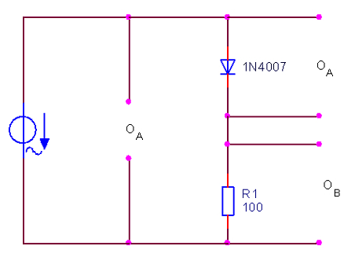

Ans. / measure the ch/s of silicon diode

1. Set the output voltage of the function generator to a value of approx. 4 V. Connect the measurement terminals of the oscilloscope to the prescribed positions and set the instrument to the parameters specified above. Set the oscilloscope to the X/Y display modus. Record the characteristic in the diagram.

Ans. /



1. How high is the breakdown voltage of the diode?

UBreak = ______________________V

1. Exchange the 100 ohm resistor for a 330 ohm resistor. How does the reversing voltage respond now?
2. It remains approximately constant.
3. The reversing voltage is tripled.
4. The reversing voltage is reduced to one third.

=========================================================================

**2- Half wave rectifier**

(2)

1. For the circuit shown in the figure

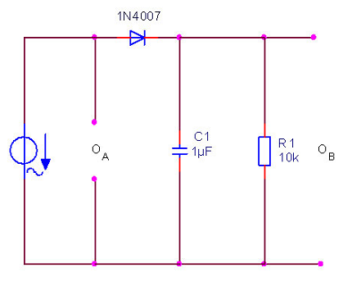

1. What is the function of this circuit?

Ans. / clipping for the negative cycles of input signal and decrease ripples

1. Trace the expected output at the oscilloscope (X-T) for 5V peak sinusoidal input signal.

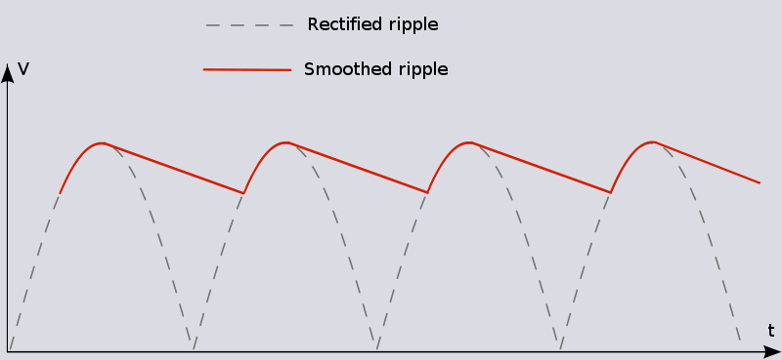

1. Remove the capacitor and re-trace the output

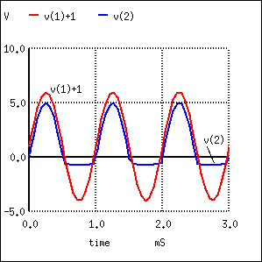

1. What occurs by changing the resistor to 4.7K, and 100K?

Ans. / as resistor increase, the ripples decreases and the output smooth to dc.

1. Which of the following statements are correct? The ripple...
2. Becomes lower as the load increases.
3. Always remains the same.
4. Becomes lower as the load decreases.

==========================================================================

1. Describe how we can test a semiconductor diode with a multimeter.

Ans. / by adjust the multimeter to ohm scale it reads small value in forward directions and large value in reverse direction

==========================================================================

1. Write on uses of normal diode in engineering applications, and then Show the difference between the characteristics of silicon and germanium diode.

Ans. / Modern diodes are semiconductor components, which have attained supreme importance in electrical engineering and electronics thanks to their compact design and robust nature. In the past, vacuum diodes were used with a heated cathode and anode. Today, silicon isthe most important basic material.

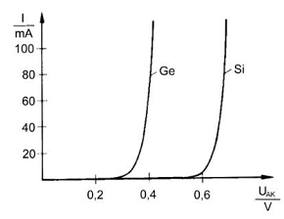

========================================================================

1. "Diodes have Forward or conducting direction and Reverse or blocking properties", discuss this statement briefly.

Ans. / Forward or conducting direction:

Diodes have a very low forward voltage of approx. 0.7 V for silicon and 0.3 V for germanium diodes. Furthermore, they have a forward DC resistance which can be seen in the slope of the diode characteristic.

Diodes are subject to limits which may not be exceeded. In the forward range

it is the maximum permissible current in particular that may not be exceeded.

zReverse or blocking properties:

Diodes have only a finite voltage-proof capability, which however can vary from type to type. In the reversing or blocking range it is the maximum permissible blocking voltage that must be taken into consideration.

===========================================================================